**1.What is mobile application development? Explain types of mobile application.**

Ans :-

Mobile application development is the process of designing, building, and maintaining software applications that run on mobile devices such as smartphones and tablets. These applications can be pre-installed or downloaded from app stores. The development process includes designing the user interface (UI), coding, testing, and deploying the application.

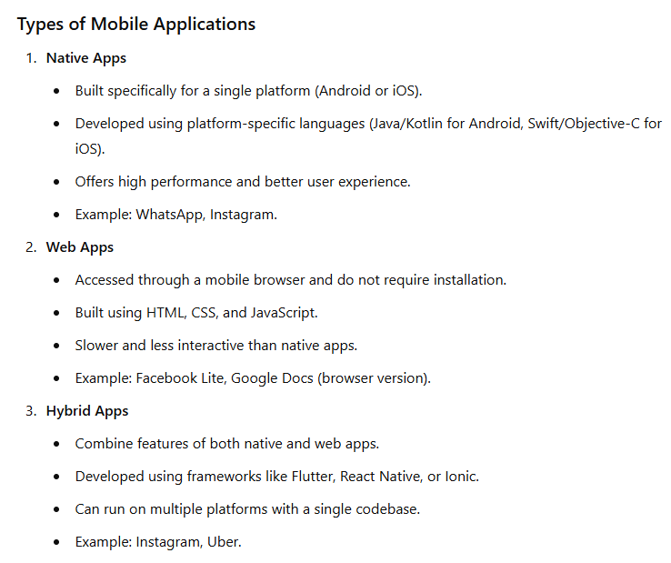

**2.Discuss the formation and objectives of the Open Handset Alliance (OHA). How has this consortium influenced the development, standardization, and adoption of the Android platform globally?**

Ans:-

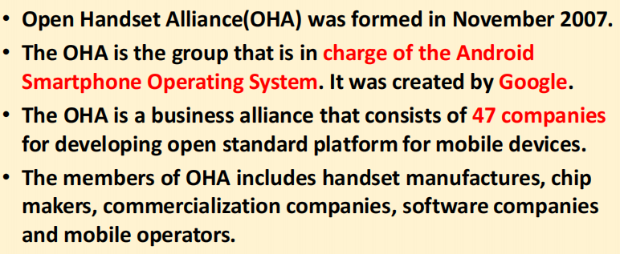

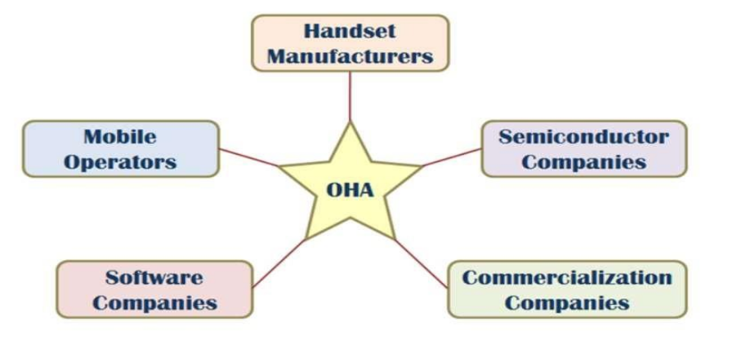

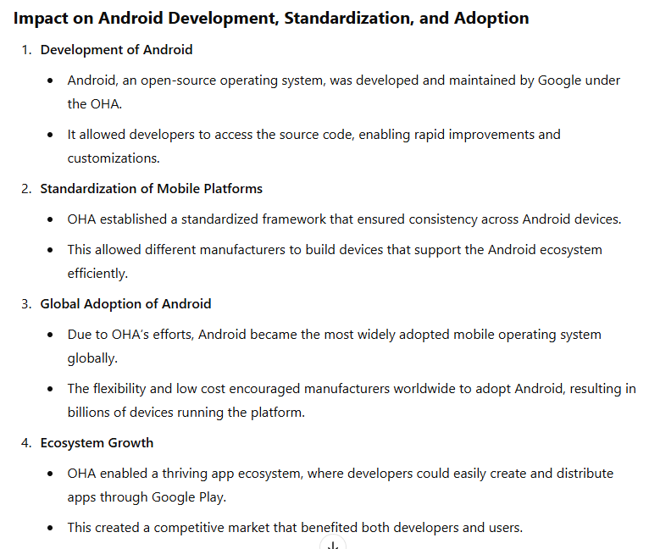

**3.Provide a step-by-step guide on how to download and install Android Studio on a**

**Windows operating system. Include key considerations such as system requirements, setup instructions, and common troubleshooting tips.**

Ans:-

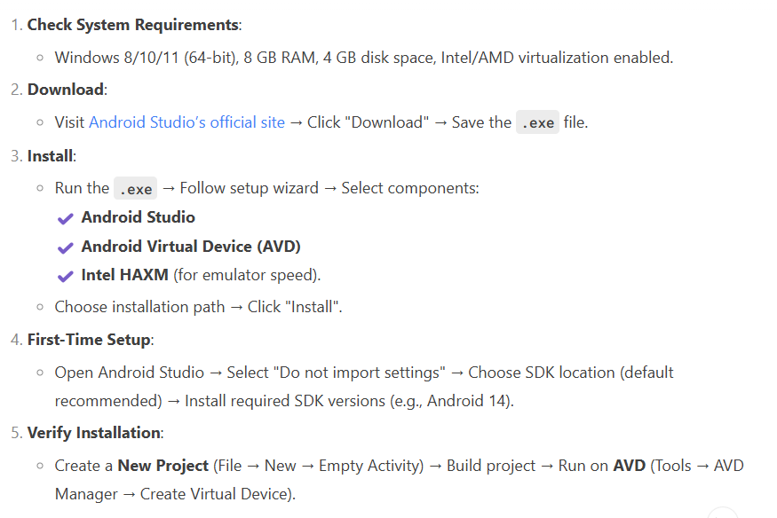

**4.What are the features of android?**

Ans :-

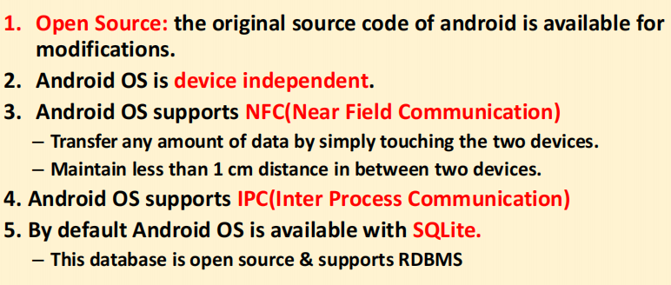

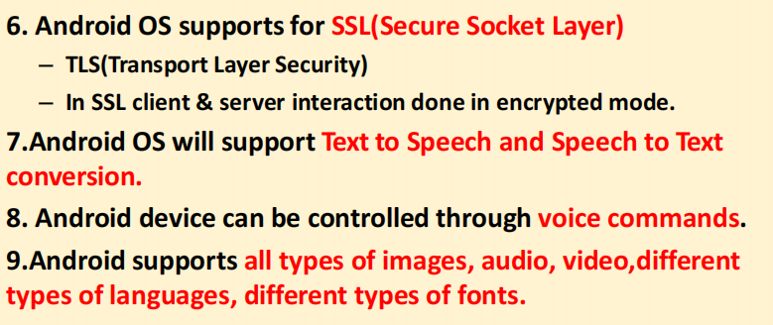

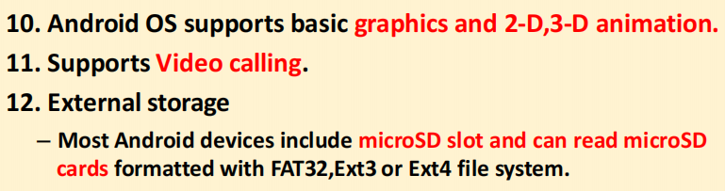

**5. Explain android architecture with diagram.**

Ans :-

Android is a mobile platform which consists three things:

–Android OS

–Middleware

–Key Applications

• Android OS is a software stack of different layers, where each

layer is a group of several program components.

• Android has the following layers:

1. Applications

2. Application Framework

3. Libraries

4. Android Runtime

5. Linux Kernel

**NOTE : Refer architecture diagram given in ppt.**

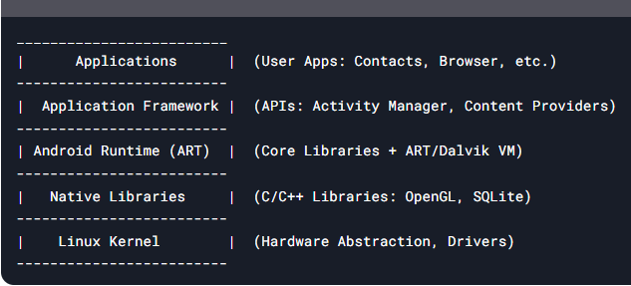

1. **Applications:-**

• Written using Java Language

– Email Client

– SMS Program

– Maps

– Browser

– Calendar

– Contacts

• Supports Parallel running

• No compulsory applications

**2.Application Framework:-**

• The Application Framework layer provides many higher-level

services to applications in the form of Java classes.

• Application developers are allowed to make use of these

services in their applications.

• The Android framework includes the following key services −

• Activity Manager − Controls all aspects of the application lifecycle and

activity stack.

• Content Providers − Allows applications to publish and share data with

other applications.

• Resource Manager − Provides access to non-code embedded resources

such as strings, color settings and user interface layouts.

• Notifications Manager − Allows applications to display alerts and

notifications to the user.

• View System − An extensible set of views used to create application user

interfaces.

**3.Libraries:-**

• Useful to develop any third-party application.

• Native libraries are written in a language that compiles to

native code for the platform it run.

1. SQLite - Responsible for Database Operation

2. Free Type - Font Support

3. Media F/W - Audio,Video Format

4. Open GL(Open Google Library) - 2D,3D Graphics Support

5. SSL - Encrypted Communication between Client and Server

6. SGL (Scalable Graphics Libraries)- For Basic Graphics Support

**4.Android Runtime:-**

• Android Runtime consists of Core Libraries and Dalvik Virtual

Machine.

• Core Libraries are written in C/C++ languages. This libraries

are helpful for runtime environment. Some of the core

libraries are Data Structure, File Access, Network Access,

Utilities and Graphics.

**DVM(Dalvik Virtual Machine)**

**• Runtime environment for running android application.**

**• JVM is used to run high-end applications while DVM is used**

**for small-end applications.**

**• DVM was first written by "Dan Bornstein“**

**• Unlike JVM, the DVM does not run .class files but it runs .dex**

**files.**

**• .dex files are built from .class file at the time of compilation**

**and provide higher efficiency in row resource environments.**

**5.Linux Kernel :-**

• Linux Kernel is a Root layer of android Architecture which is

responsible for device drivers(display, camera, Bluetooth,

flash, web driver, usb, keypad,wifi etc.)

• power management, memory management and resource

management.

1. **Explore the components of the Android SDK essential for application development. Explain the role of tools like Android Debug Bridge (ADB), SDK Manager, and Android Virtual Device (AVD) Manager in the Android development workflow.**

Ans :-

The Android SDK is a collection of software development tools and libraries required to develop Android applications. Among its many components, three tools stand out as essential for the development workflow: Android Debug Bridge (ADB), SDK Manager, and Android Virtual Device (AVD) Manager.

**Android SDK Essentials (Short & Simple)**

**1.SDK Tools:**

Basic tools for building Android apps.

Includes emulator, debugging tools, etc.

**2.Platform Tools:**

Tools for working with Android devices (real or virtual).

Includes ADB (Android Debug Bridge).

**3.Build Tools:**

Help compile your code into an app (APK).

Includes tools like aapt, dx, zipalign.

**4.SDK Platforms:**

APIs for different Android versions (like Android 11, 12, etc.)

You need this to build apps for a specific Android version.

**5.System Images:**

Required to run Android emulators.

Simulate a real Android OS for testing.

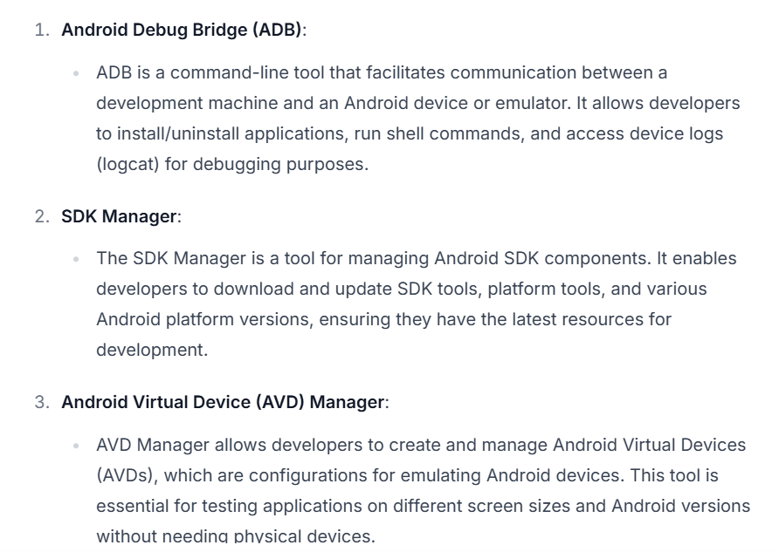

**7.Define and explain key Android terminologies such as Intent, Activity, Service, Broadcast Receiver, and Content Provider. How do these components interact within the Android framework to facilitate application development?**

Ans:-

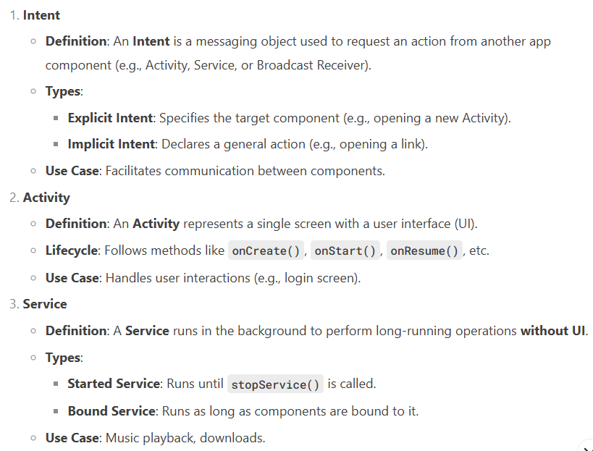

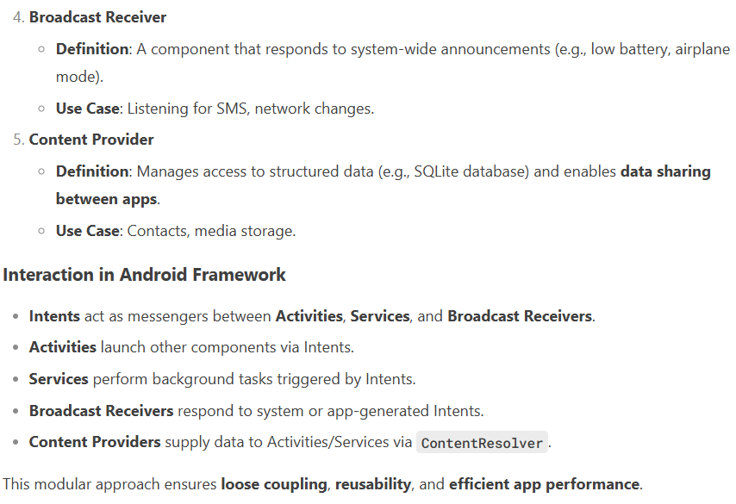

**8.Discuss the concept of Application Context in Android development. How is it different from Activity Context, and what are its primary use cases in managing application-level resources and data?**

Ans :-

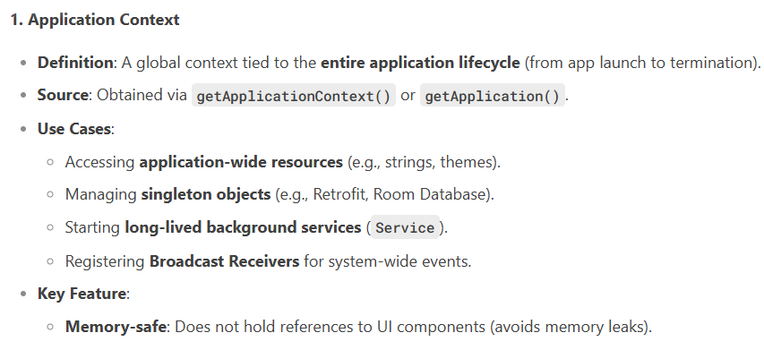

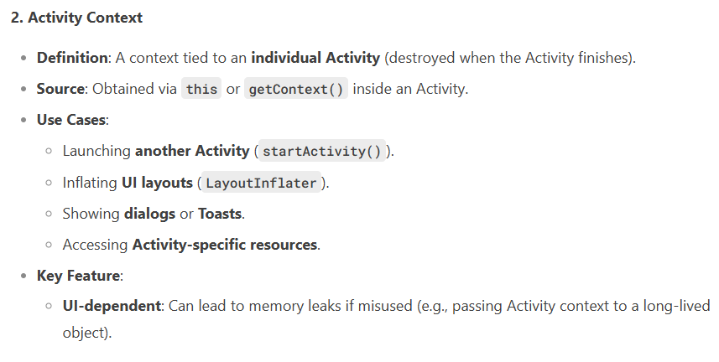

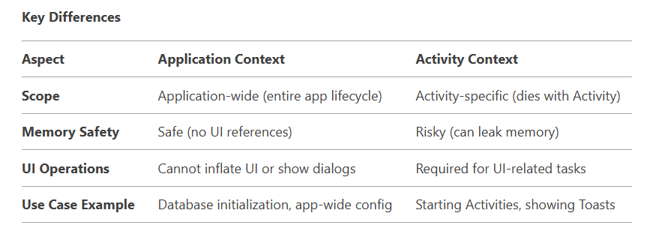

**EXAMPLE:** public class MainActivity extends AppCompatActivity {

@Override

protected void onCreate(Bundle savedInstanceState) {

super.onCreate(savedInstanceState);

setContentView(R.layout.activity_main);

// Application context example

Toast.makeText(getApplicationContext(), "Hello from Application Context!", Toast.LENGTH_SHORT).show();

// Activity context example

Toast.makeText(this, "Hello from Activity Context!", Toast.LENGTH_SHORT).show();

}}

**9.Differentiate between Emulator and simulator**

Ans :-

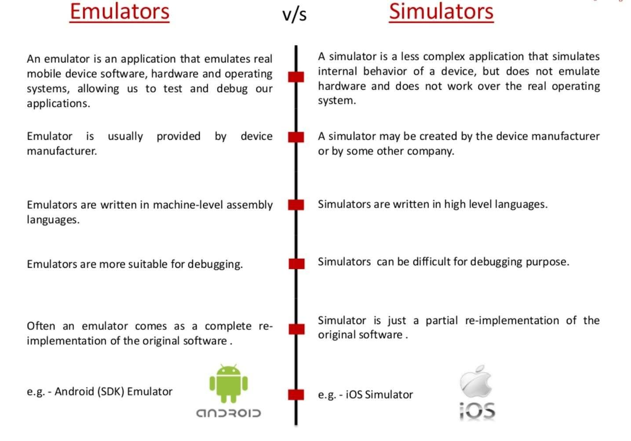

**10. Explain the concept of Intents in Android and their role in inter-component**

**communication. Provide examples of explicit and implicit intents, and discuss how intent filters facilitate dynamic component resolution at runtime.**

Ans :-

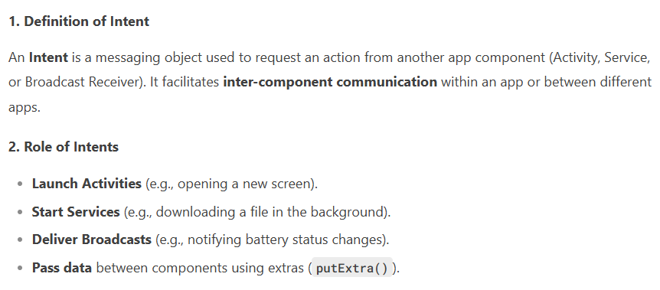

1. **Types of Intents :-**

1. Explicit intent: Launching the new Activity by Class Name

Usage: 1)Start another activity within the same application.

2)Pass data between activities.

Example:

Intent intent = new Intent(MainActivity.this,SecondActivity.class);

startActivity(intent);

1. Implicit intent: Launching an Activity Belonging to Another Application

Usage: Open URLs, dial numbers, send SMS, open camera, etc.

Example:

Intent intent = new Intent(Intent.ACTION_VIEW, Uri.parse("https://www.google.com"));

startActivity(intent);

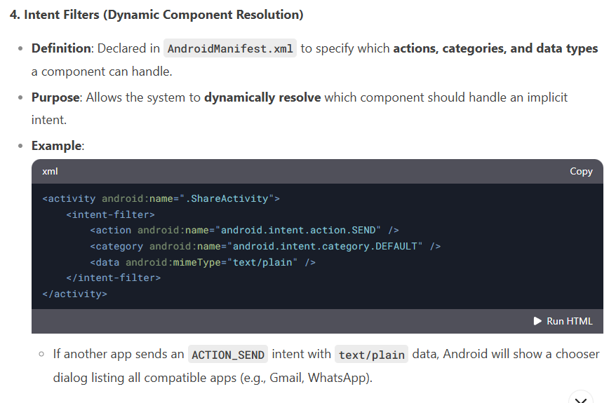

**11.Examine the lifecycle of Android activities in detail. Discuss the different states an activity transitions through and explain how developers can leverage lifecycle methods to manage application state and resources effectively.**

Ans :-

public class MyActivity extends Activity

{

protected void onCreate(Bundle savedInstanceState);

protected void onStart();

protected void onRestart();

protected void onResume();

protected void onPause();

protected void onStop();

protected void onDestroy();

}

